ASSIGNMENT 2 MAST30025 2021 R CODE

#Question 2 Part a:

n = 7  
p = 4  
X = matrix(c(rep(1,n),32,19.5,13.3,13.3,5,7.1,34.5,84.9,306.6,562,562,390.6,2175,623.5,10,9,5,5,5,3,7),n,p)  
y = c(37.9,42.2,47.3,43.1,54.8,47.1,40.3)  
b = solve(t(X)%*%X,t(X)%*%y)  
b

## [,1]  
## [1,] 58.369312708  
## [2,] -0.346291960  
## [3,] -0.002900359  
## [4,] -0.887671692

s2 = sum((y-X%*%b)^2)/(n-p)  
s2

## [1] 13.06871

#Question 2 Part b:

xst = as.vector(c(1,10,100,6))  
xst %*% b + c(-1,1)*qt(0.95,df=n-p)*sqrt(s2 * t(xst) %*% solve(t(X)%*%X) %*% xst)

## Warning in c(-1, 1) * qt(0.95, df = n - p) * sqrt(s2 * t(xst) %*% solve(t(X) %*% : Recycling array of length 1 in vector-array arithmetic is deprecated.  
## Use c() or as.vector() instead.

## Warning in xst %*% b + c(-1, 1) * qt(0.95, df = n - p) * sqrt(s2 * t(xst) %*% : Recycling array of length 1 in array-vector arithmetic is deprecated.  
## Use c() or as.vector() instead.

## [1] 43.27252 55.30814

#Question 2 Part c:

#Attempt 1   
tst = c(0,1,0,-1)  
#Calculating the Sample Standand Derivation!  
s = sqrt(s2)  
  
#Standand error for beta1 - beta3  
s*sqrt(t(tst)%*%solve(t(X)%*%X)%*%tst)

## [,1]  
## [1,] 1.388968

#Question 2 Part d:

#Attempt 1  
SSRes = sum((y-X%*%b)^2)  
SSReg = sum(y^2)-SSRes  
Fstat = (SSReg/p)/(SSRes/(n-p))  
pf(Fstat,p,n-p,lower=F)

## [1] 0.000363714

#We reject the null under 5% signifance level!

#Question 2 Part e:

#Slide 61-63 IFTFRM

SSReg = t(y) %*% X %*% b - sum(y)^2 / n  
SSReg

## [,1]  
## [1,] 149.7282

SSRes = s2*(n-p)  
SSRes

## [1] 39.20612

Fstat = (SSReg/(p-1))/(SSRes/(n-p))   
Fstat

## [,1]  
## [1,] 3.819

pf(Fstat, p-1, n-p, lower.tail = FALSE)

## [,1]  
## [1,] 0.1500833

#We do not reject the null hypothesis of the model relevance!

#Question 4 Part a:

data(mtcars)  
mtcars = log(mtcars[, c(1,3:7)])  
pairs(mtcars,cex=0.5)

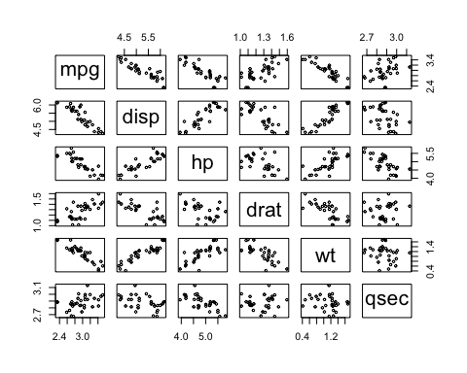 #COMMENT HERE: Looking at miles per gallon against the other variables, there is evidence of a linear relationship with displacement,gross horsepower,rear axle ratio,weight and a quarter mile time!

#Question 4 Part b:

model0 = lm(mpg ~ 1, data=mtcars)  
add1(model0, scope = ~.+disp+hp+drat+wt+qsec, test = "F")

## Single term additions  
##   
## Model:  
## mpg ~ 1  
## Df Sum of Sq RSS AIC F value Pr(>F)   
## <none> 2.74874 -76.547   
## disp 1 2.25596 0.49277 -129.550 137.3427 1.006e-12 ***  
## hp 1 1.96733 0.78140 -114.797 75.5310 1.080e-09 ***  
## drat 1 1.23131 1.51742 -93.559 24.3435 2.807e-05 ***  
## wt 1 2.21452 0.53422 -126.966 124.3596 3.406e-12 ***  
## qsec 1 0.47755 2.27119 -80.654 6.3079 0.01763 *   
## ---  
## Signif. codes: 0 '***' 0.001 '**' 0.01 '*' 0.05 '.' 0.1 ' ' 1

#We take out the displacement variable

model1 = lm(mpg ~ 1+disp, data=mtcars)  
add1(model1, scope = ~.+hp+drat+wt+qsec, test = "F")

## Single term additions  
##   
## Model:  
## mpg ~ 1 + disp  
## Df Sum of Sq RSS AIC F value Pr(>F)   
## <none> 0.49277 -129.55   
## hp 1 0.045531 0.44724 -130.65 2.9523 0.09641 .  
## drat 1 0.001383 0.49139 -127.64 0.0816 0.77711   
## wt 1 0.098796 0.39398 -134.71 7.2722 0.01154 *  
## qsec 1 0.000308 0.49247 -127.57 0.0181 0.89382   
## ---  
## Signif. codes: 0 '***' 0.001 '**' 0.01 '*' 0.05 '.' 0.1 ' ' 1

#Take out the weight variable

model2 = lm(mpg ~ 1+disp+wt, data=mtcars)  
add1(model2, scope = ~.+hp+drat+qsec, test = "F")

## Single term additions  
##   
## Model:  
## mpg ~ 1 + disp + wt  
## Df Sum of Sq RSS AIC F value Pr(>F)   
## <none> 0.39398 -134.71   
## hp 1 0.078605 0.31537 -139.83 6.9789 0.01334 *  
## drat 1 0.007358 0.38662 -133.31 0.5329 0.47146   
## qsec 1 0.057788 0.33619 -137.79 4.8130 0.03671 *  
## ---  
## Signif. codes: 0 '***' 0.001 '**' 0.01 '*' 0.05 '.' 0.1 ' ' 1

#We take out horsepower  
model3 = lm(mpg ~ 1+disp+wt+hp, data=mtcars)  
add1(model3, scope = ~.+drat+qsec, test = "F")

## Single term additions  
##   
## Model:  
## mpg ~ 1 + disp + wt + hp  
## Df Sum of Sq RSS AIC F value Pr(>F)  
## <none> 0.31537 -139.83   
## drat 1 0.0000095 0.31536 -137.83 0.0008 0.9774  
## qsec 1 0.0033067 0.31206 -138.17 0.2861 0.5971

#The final variables are disp,wt and hp!

#Question 4 Part c:

model = step(model0, scope = ~ .+disp+hp+drat+wt+qsec)

## Start: AIC=-76.55  
## mpg ~ 1  
##   
## Df Sum of Sq RSS AIC  
## + disp 1 2.25596 0.49277 -129.550  
## + wt 1 2.21452 0.53422 -126.966  
## + hp 1 1.96733 0.78140 -114.797  
## + drat 1 1.23131 1.51742 -93.559  
## + qsec 1 0.47755 2.27119 -80.654  
## <none> 2.74874 -76.547  
##   
## Step: AIC=-129.55  
## mpg ~ disp  
##   
## Df Sum of Sq RSS AIC  
## + wt 1 0.09880 0.39398 -134.710  
## + hp 1 0.04553 0.44724 -130.652  
## <none> 0.49277 -129.550  
## + drat 1 0.00138 0.49139 -127.640  
## + qsec 1 0.00031 0.49247 -127.570  
## - disp 1 2.25596 2.74874 -76.547  
##   
## Step: AIC=-134.71  
## mpg ~ disp + wt  
##   
## Df Sum of Sq RSS AIC  
## + hp 1 0.078605 0.31537 -139.83  
## + qsec 1 0.057788 0.33619 -137.79  
## <none> 0.39398 -134.71  
## + drat 1 0.007358 0.38662 -133.31  
## - wt 1 0.098796 0.49277 -129.55  
## - disp 1 0.140243 0.53422 -126.97  
##   
## Step: AIC=-139.83  
## mpg ~ disp + wt + hp  
##   
## Df Sum of Sq RSS AIC  
## - disp 1 0.006635 0.32201 -141.16  
## <none> 0.31537 -139.83  
## + qsec 1 0.003307 0.31207 -138.17  
## + drat 1 0.000010 0.31536 -137.83  
## - hp 1 0.078605 0.39398 -134.71  
## - wt 1 0.131870 0.44724 -130.65  
##   
## Step: AIC=-141.17  
## mpg ~ wt + hp  
##   
## Df Sum of Sq RSS AIC  
## <none> 0.32201 -141.16  
## + disp 1 0.00664 0.31537 -139.83  
## + qsec 1 0.00557 0.31644 -139.72  
## + drat 1 0.00112 0.32089 -139.28  
## - hp 1 0.21221 0.53422 -126.97  
## - wt 1 0.45939 0.78140 -114.80

#AIC is -139.83

#Question 4 Part d:

model

##   
## Call:  
## lm(formula = mpg ~ wt + hp, data = mtcars)  
##   
## Coefficients:  
## (Intercept) wt hp   
## 4.8347 -0.5623 -0.2553

#Were are dealing with a log transformation! #Final model is log(mpg) = 4.8347 - 0.2553log(hp) - 0.5623log(wt) + e #Take the exponential on both sides of the linear model # mpg = exp(4.8347) - hp(0.2553)-wt(0.5623) + e’ # Where e’ is exp(e)

#Question 4 Part e:

plot(model, which=1)

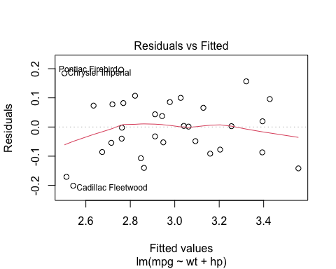

plot(model, which=2)

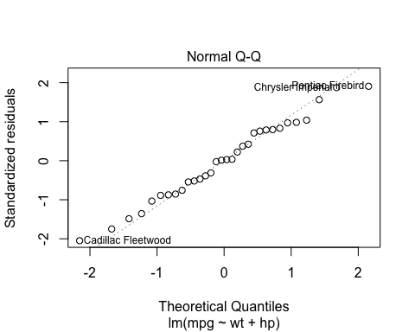

plot(model, which=3)

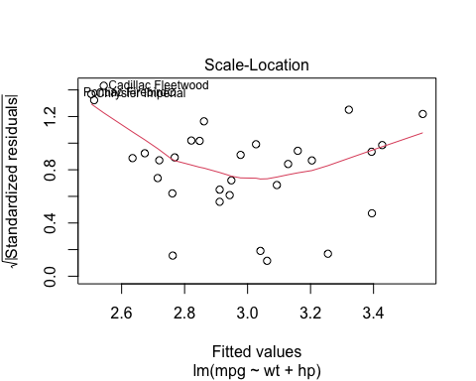

plot(model, which=5)

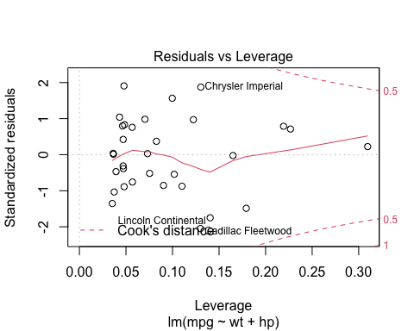 #Diagnostic plots show a reasonable fit to linear model assumptions. About the only area of concern is a slight positive trend for higher fitted values and moderate leverages, but this does not appear to be too alarming.